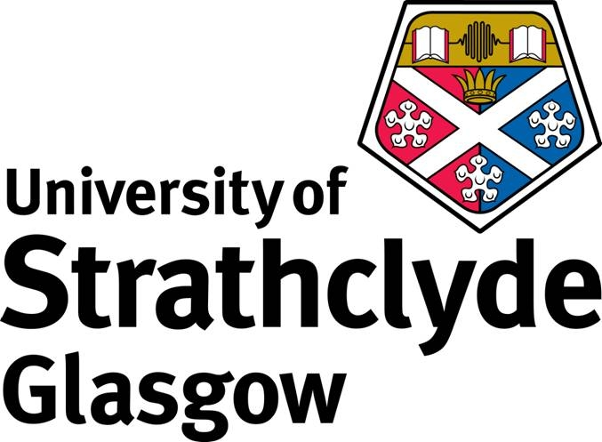

University of Strathclyde

John Anderson Scholarship Programme

Please note that all questions on this application form must be answered in full
Do not attach personal statements or CVs to your application
Do not send transcripts or other accompanying paperwork

1. Family name:

2. First names:

3. Date of Birth: Sex (please circle): M F

5. Nationality:

6. Country of Residence:

7. Permanent contact address:

Please note that you may need to be contacted at very short notice and it is essential that you supply a current phone/fax and e-mail

Telephone:
Fax:
e-mail:

8. Details on Courses applied for

Application reference number

Course title and Subject:

Department:

Length of course:

Start Date:

9. Please tell us how you intend to finance your proposed study at the University of Strathclyde.

10. Have you applied for any other scholarships or bursaries? (Please give details)

11. Qualifications and Employment

Are you currently studying? (please circle) Y N

If so, please give details:

Please list all qualifications obtained:

Institution | Qualification | Grade | Date Obtained

Details of employment to date (if appropriate)

Additional information

Please give information in support of your application including:

- Why you wish to study in the UK and at the University of Strathclyde
- Why you wish to obtain the qualification you have indicated
- How you think you will benefit from obtaining this qualification

The deadline for returning this form is 31 May 2016. Forms received after this date will not be accepted.
Return this form to: e: international@strath.ac.uk

